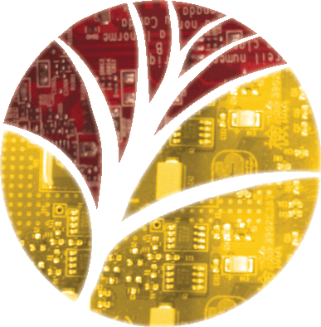
Application for
STEM Letter

Qualifications
- STEM Pathway student currently with an “A” or a “B” in the pathway class;
- 3.0 cumulative GPA or two (2) consecutive semesters with a 3.0 GPA or better;
- 50 hours of STEM service/Service Learning since the last application for a STEM Letter;
- Students can letter in STEM once per year.

Name: ________________________________________ Student Number: _________________

STEM Pathway: [ ] Biomedical [ ] Engineering [ ] By Design: ______________________
Current Pathway class: ________________________________ Current Grade: _____%

Signature of Pathway teacher: ____________________________ Date: _________________

Please list STEM community service activities, hours, and dates. Attach documentation.
Documentation can include certificates with dates and times or signed letters with dates and times. Documentation will be reviewed by STEM Advisors.
Description | Hours | Date

Do you prefer a letter or a pin? [ ] Letter [ ] Pin

Your signature: ___________________________________ Date: _____________________

Please return completed form to STEM Coordinator
Office use only
[ ] Pathway student; [ ] 3.0 Cumulative GPA or 2 consecutive sem with 3.0 or better [ ] 50 hours verified
Date submitted ___________________ Date fulfilled: ____________________

